Name: Mriganka Patra
Email: mriganka.patra@cognizant.com
Emp ID: 2415820

Day 18
Sprint 1 Submission

Task 1.3: As an admin, I want to create Users with specific access levels so that only autorized roles can access or edit data.

- Goto setup > home

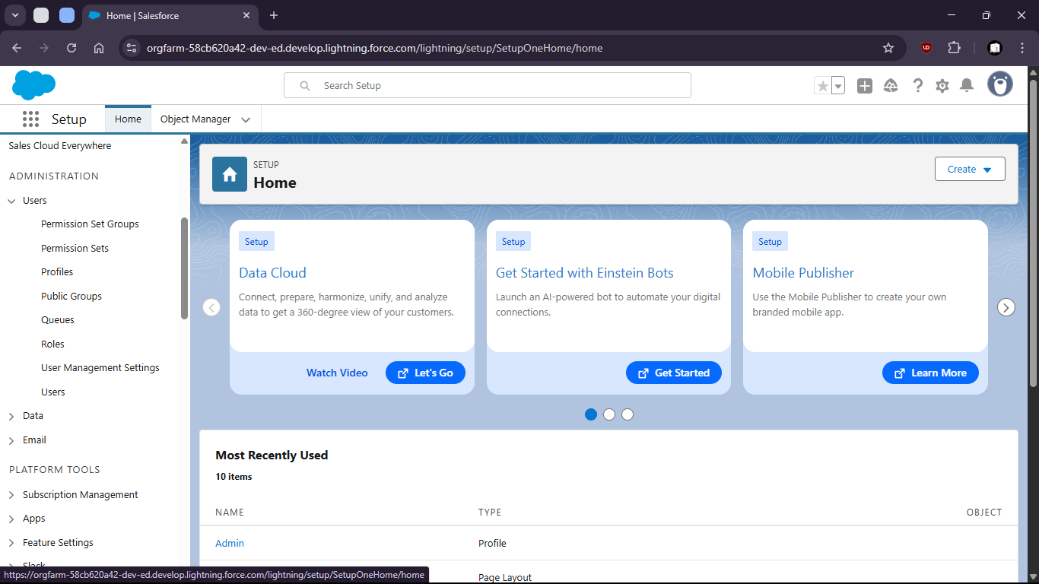

- Open profiles and create profiles

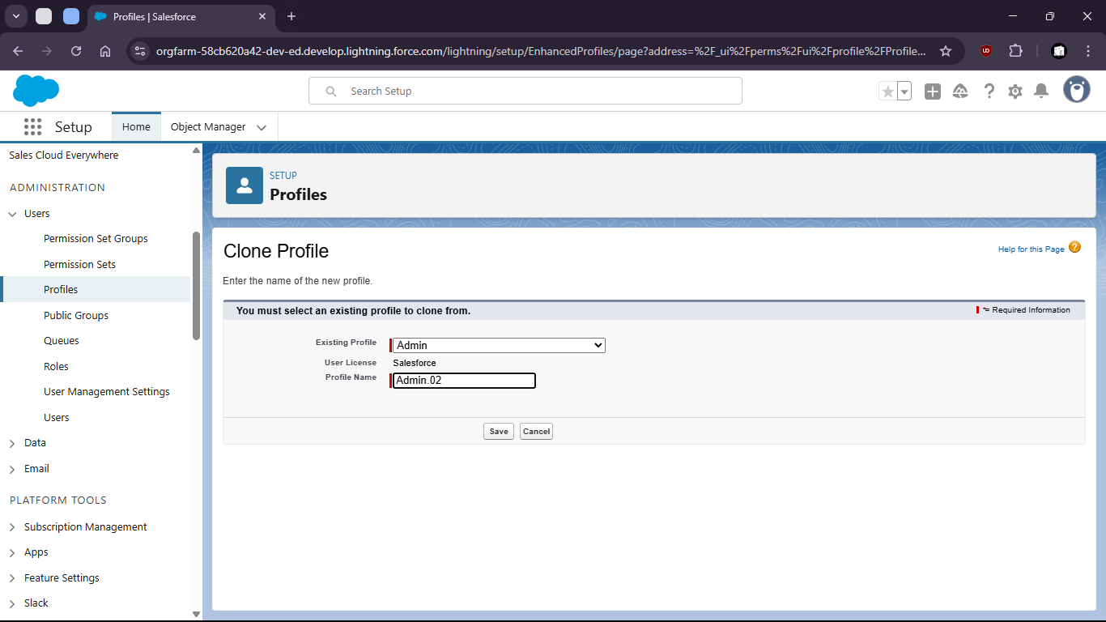

- Limit Access (field level security)

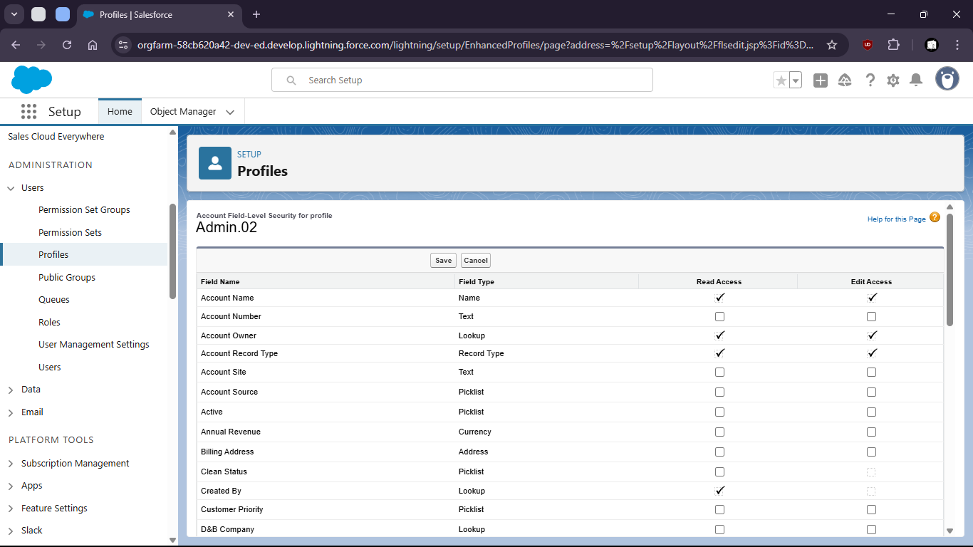
- Set standard object Permissions

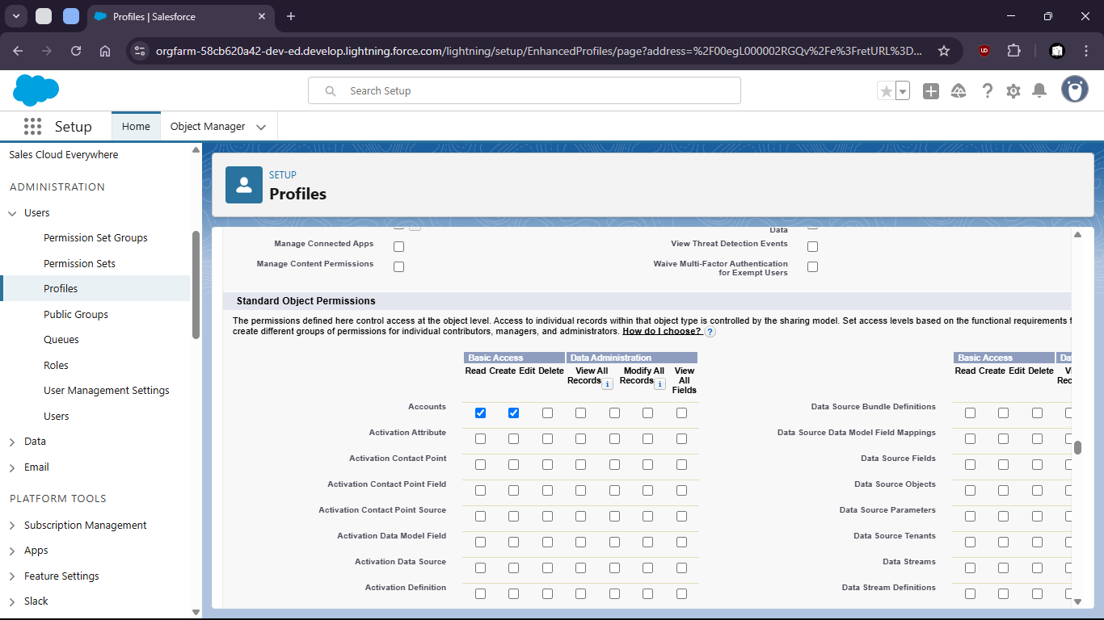

- Add to permission sets

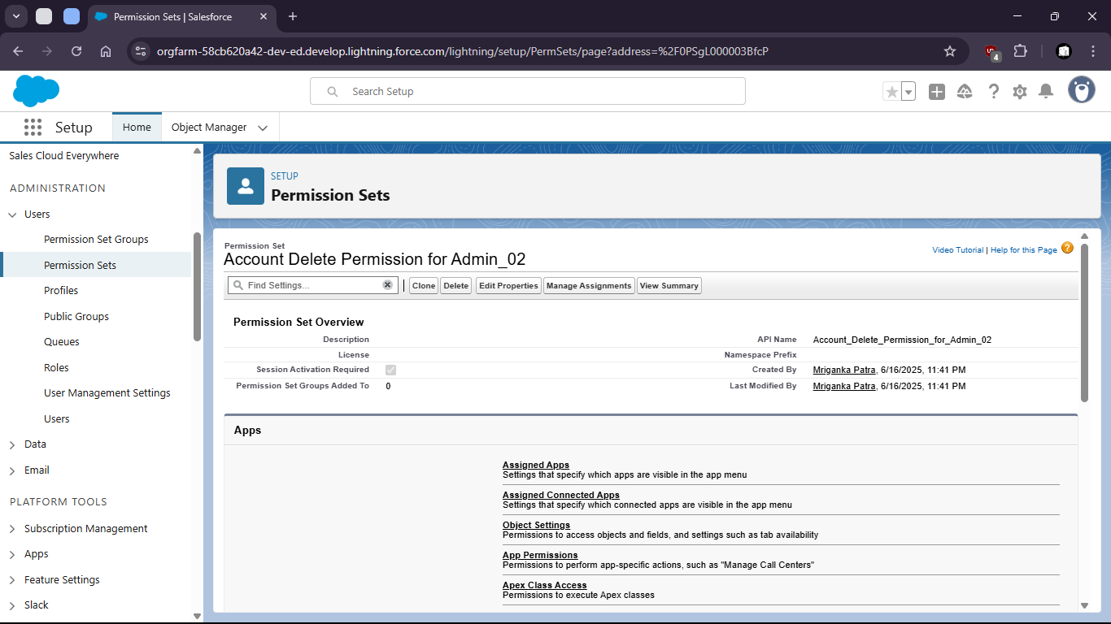
- Change object settings

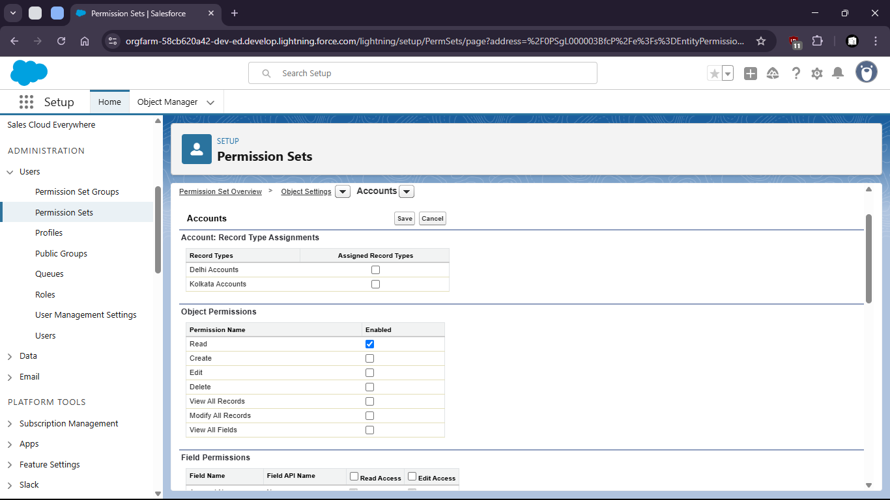
- Create new User

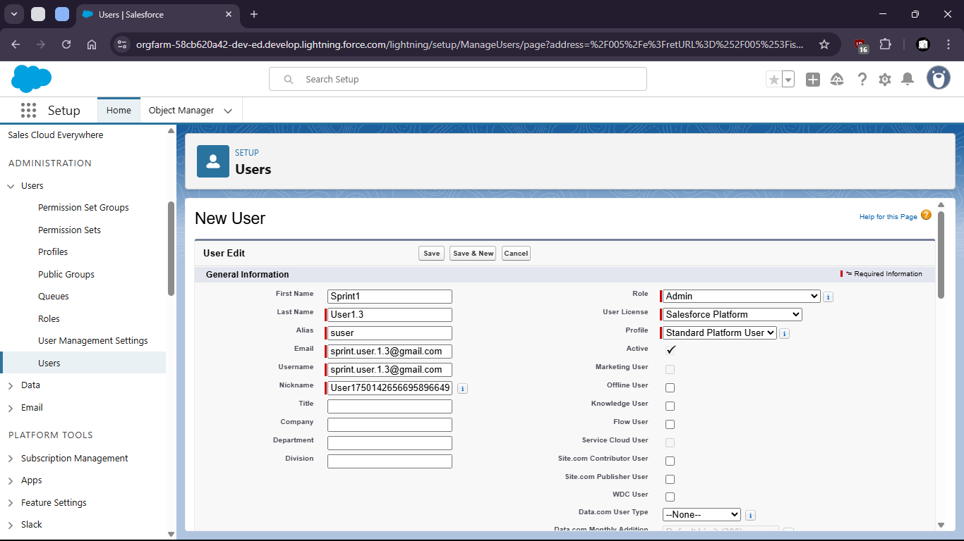
- Assign user to Permission sets

- Assigning User to Roles can also limit access levels

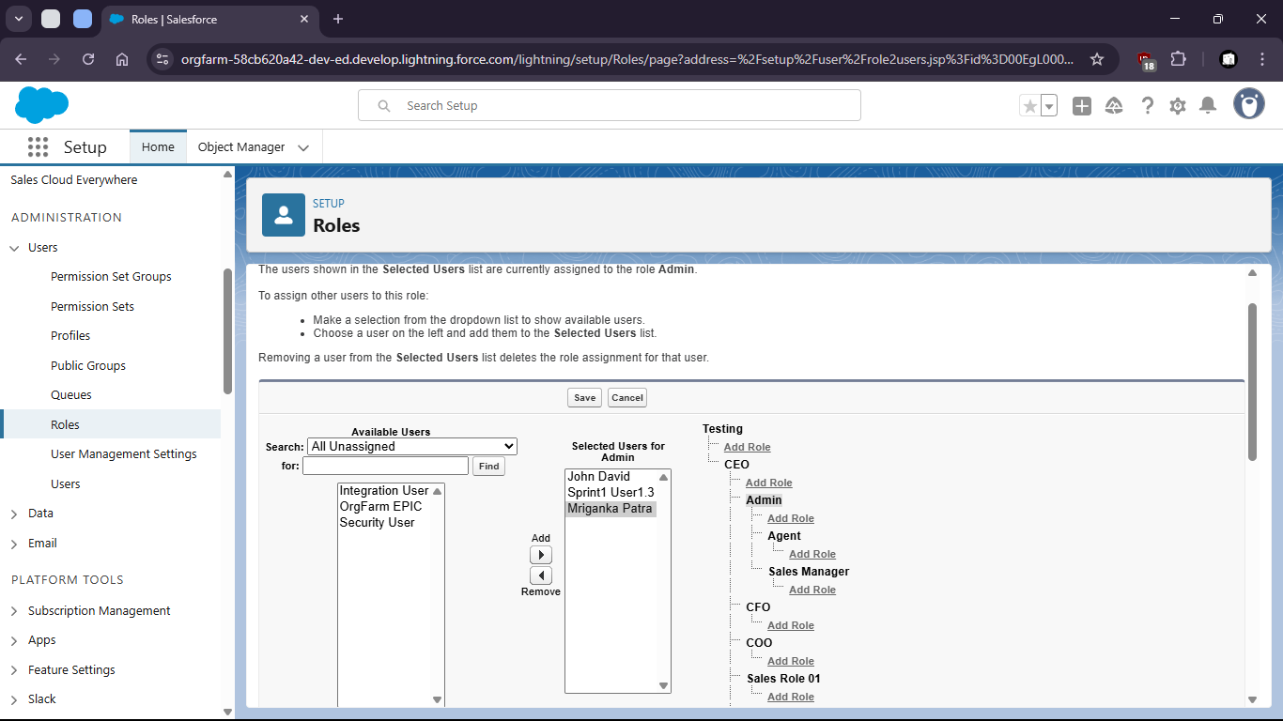
- Where the access is restricted to upper levels

